Figure 1. Clinical study design.

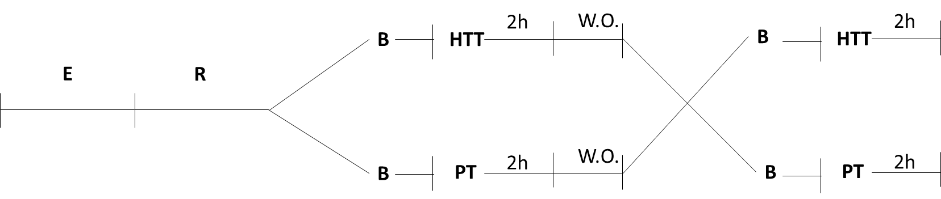
E: enrollment; R: randomization; B: Baseline; HTT: hydroxytyrosol treatment; PT: placebo treatment; W.O.: wash out.

