- Table 1: Baseline characteristics of the patients of the studies considered for the meta-analysis.
First author | Year of publication | Country | Sample size | Population | Convalescent plasma (intervention arm) | Placebo or standard treatment alone or control | Death Intervention arm | Death Control arm | Invasive ventilation intervention arm | Invasive ventilation control arm
Simonovich | 2020 | Argentina | 333 | severe disease | 228 | 105 | 25 | 12 | 19 | 10
Agarval | 2020 | India | 451 | moderate disease | 227 | 224 | 44 | 41 | 19 | 19
Li | 2020 | China | 103 | severe and life threatening disease | 52 | 51 | 8 | 12 | 14 | 11
Rasheed | 2020 | Iraq | 49 | life threatening disease | 21 | 28 | 1 | 8 | 17 | 16
Abolghasemi | 2020 | Iran | 189 | moderate -severe disease | 115 | 74 | 17 | 18 | 8 | 15
Xia | 2020 | China | 1568 | severe and life threatening disease | 138 | 1430 | 3 | 59 | 2 | 3

Table 2. Test of residual heterogeneity

Forest Plots

Fixed and Random Effects
 |  | Q |  | df |  | p
Omnibus test of Model Coefficients |  | 2.098 |  | 1 |  | 0.147
Test of Residual Heterogeneity |  | 6.501 |  | 5 |  | 0.261
Note. p -values are approximate.

Figure 1. Forest plot, mortality among groups, FE model: fixed effect model

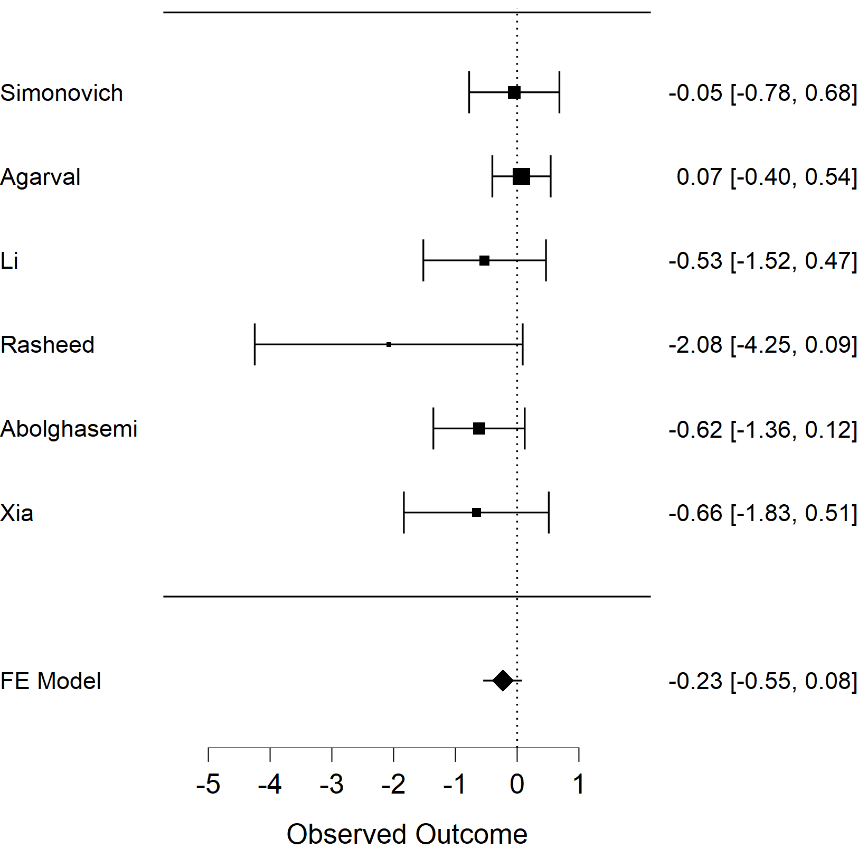

Table 3. Wald Test, Intercept -0,232[-0,546- 0,082], p 0,147

Coefficients
 |  |  |  |  |  |  |  |  |  | 95% Confidence Interval
 |  | Estimate |  | Standard Error |  | z |  | p |  | Lower |  | Upper
intercept |  | -0.232 |  | 0.160 |  | -1.449 |  | 0.147 |  | -0.546 |  | 0.082
Note. Wald test.

Figure 2. Forest plot of invasive ventilation need

Figure 3. Funnel plot of mortality.

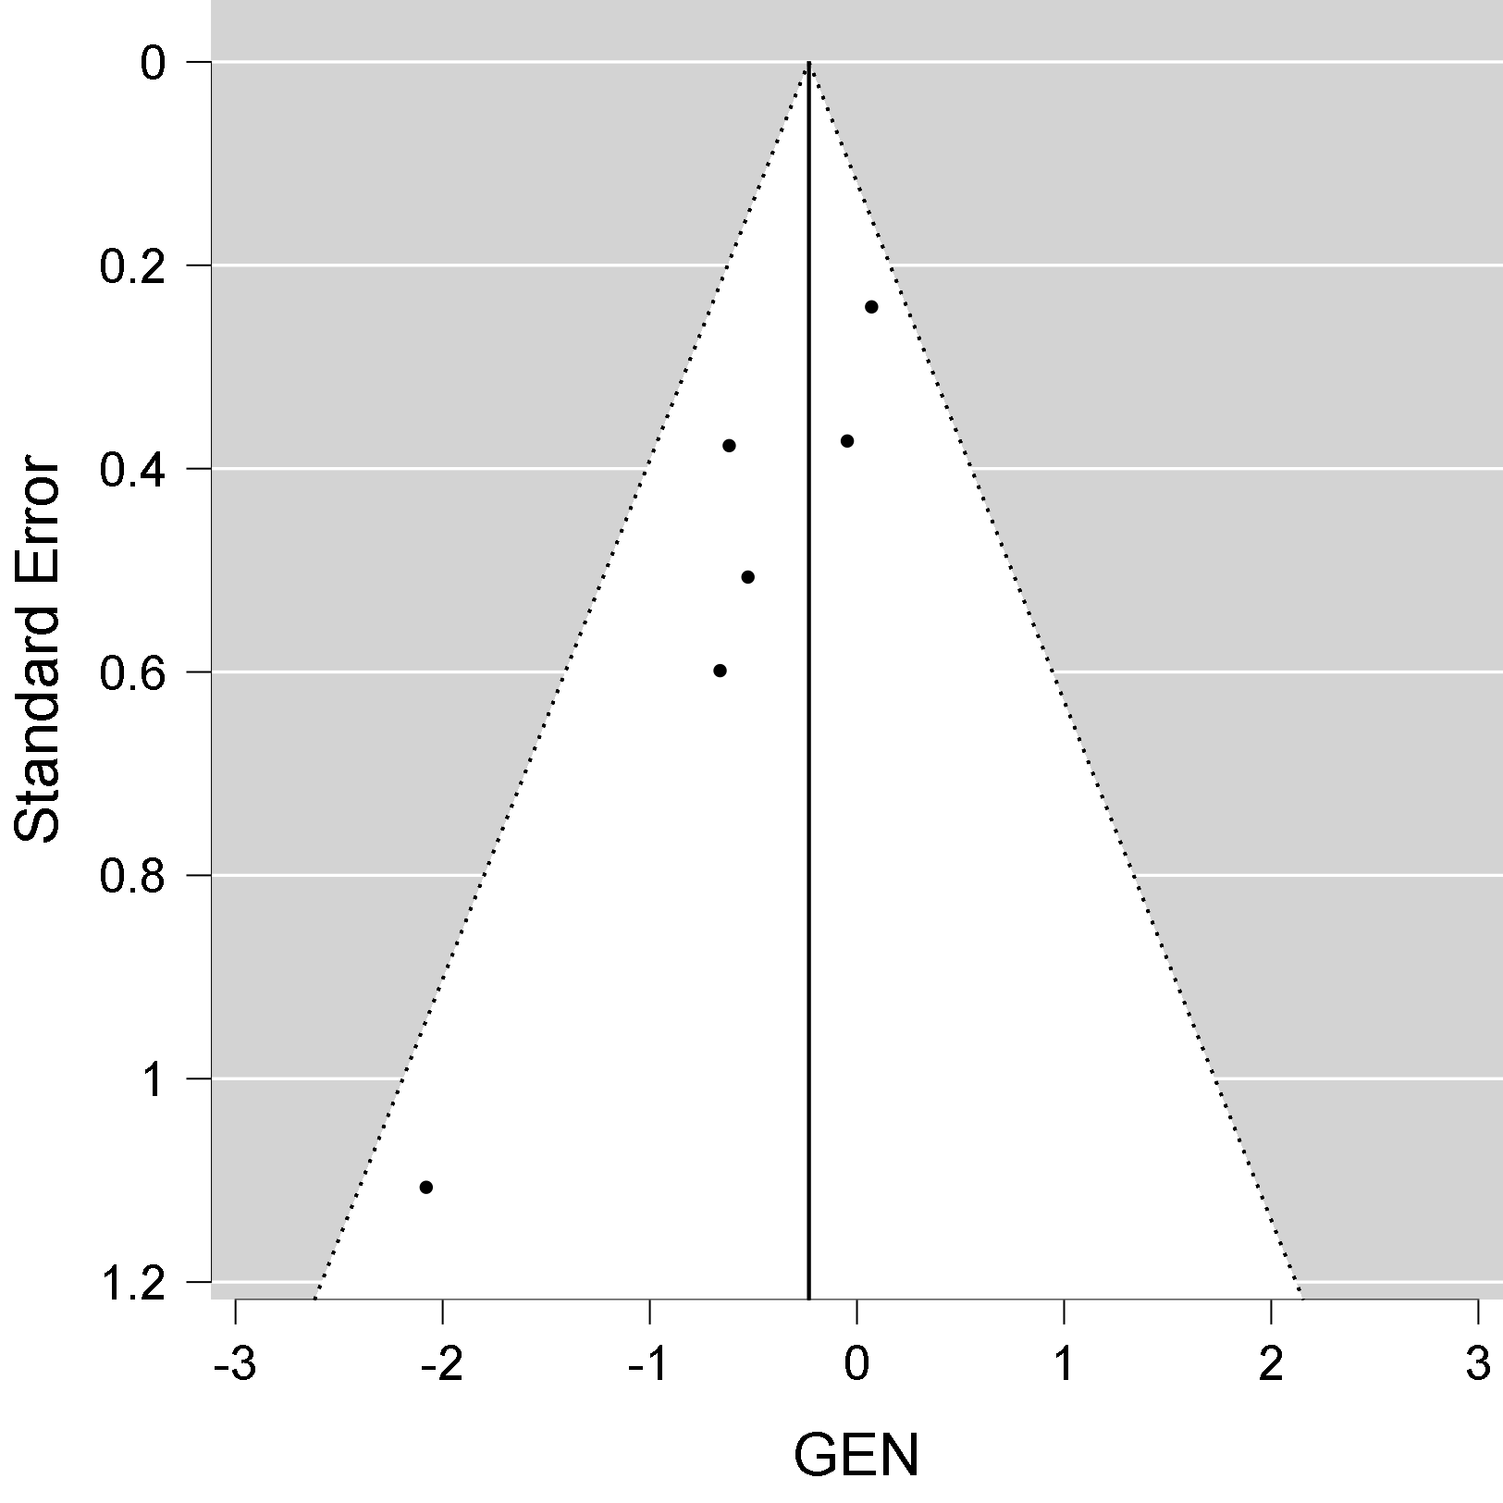

Table 4. Egger's test

Regression test for Funnel plot asymmetry ("Egger's test")
 |  | z |  | p
sei |  | -2.294 |  | 0.022

Figure 4. Funnel plot of invasive ventilation.

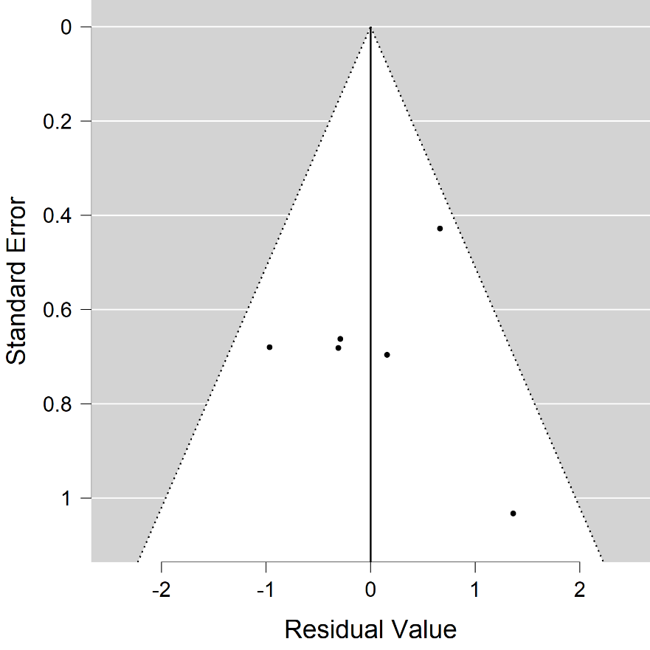

Table 5. Egger's test for the invasive ventilation

Regression test for Funnel plot asymmetry ("Egger's test")
 |  | z |  | p
sei |  | 1.095 |  | 0.274

